IBM Training day-2

Q1.wap to check whether it is positive or negative.

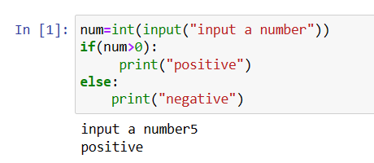

Q2.wap to program to check it is even or odd using if else.

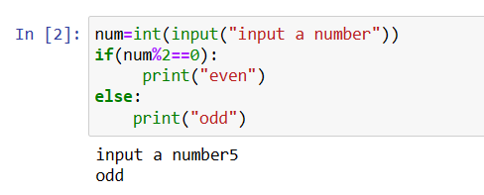

Q3.check a num divisible by 5 using if else.

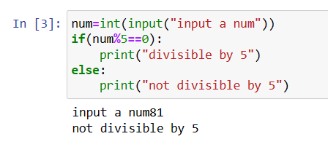

Q4.check a num divisible by 5 as well as 3.

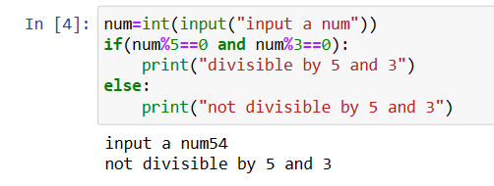

Q5.check given alphbet is vowel or not.

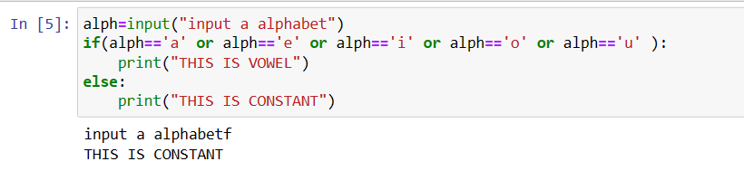

Q6. wap to input marks and check grade.

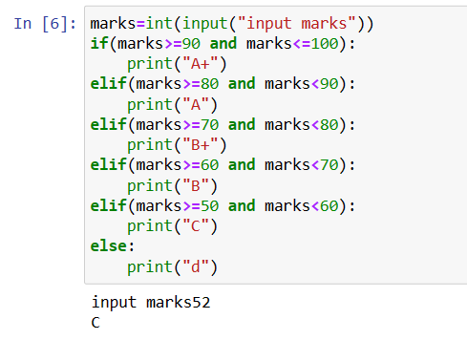

Q7. input 3 num and print largest one using elif function.

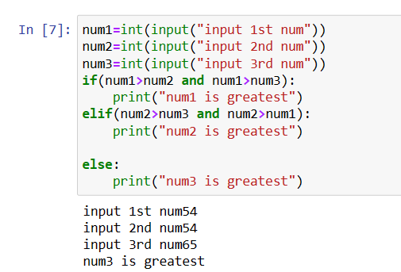

Q8. wap a program to check leap year or not.

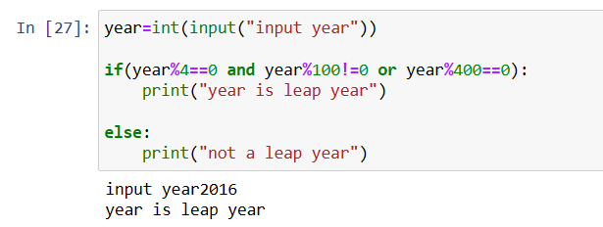

Q9. wap to input an operator and two number and perform the operation b/w the two number.

E.g

if operator is +, then print the addition of two numbers and so on...

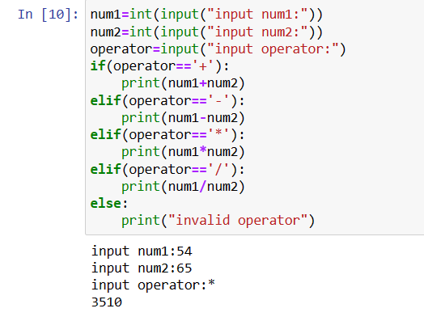

Q10. wap to print the health status of a personby following

bmi=weight divided by square of height.

weight in kg and height in cm

BMI Health Status

below 18.5 underweight

18.5 - 24.9 normal

25.0- 29.9 overweight

30.0 and above obese

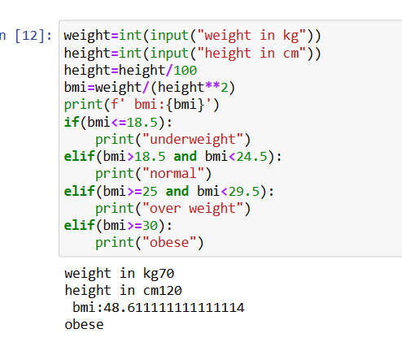

Q11. input three no. and arrange in ascending order

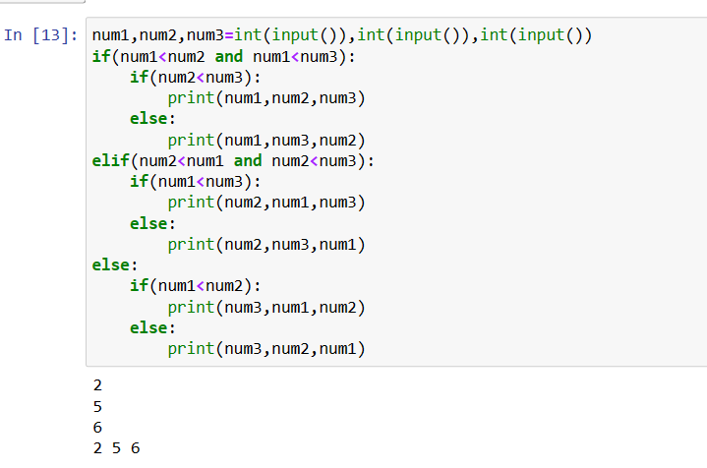

Q12. input 3 number and find largest no.

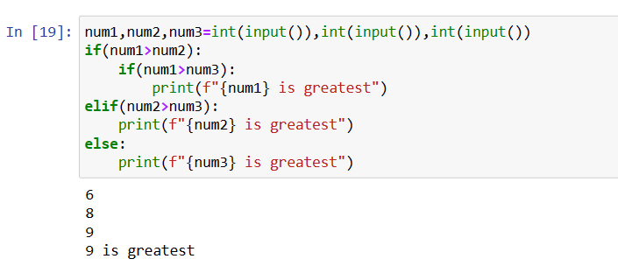

Q13. print 1 to 21

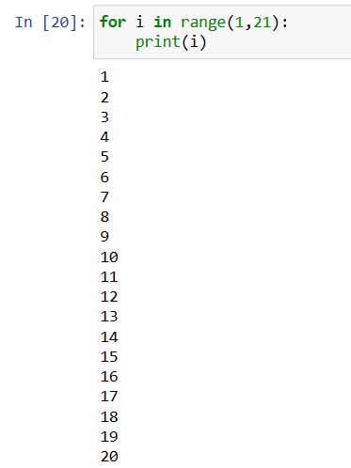

Q14. wap to print 10 to 20.

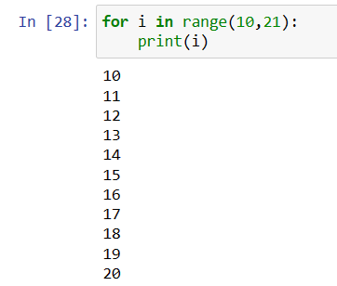

Q15. wap to print sum of odd and even no. b/w 10 and 20. 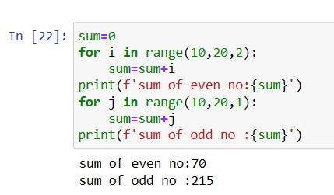

Q16. wap to calculate factorial of a number.

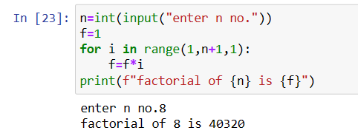

Q17. WAP TO print fibonacci series usinf for loop.

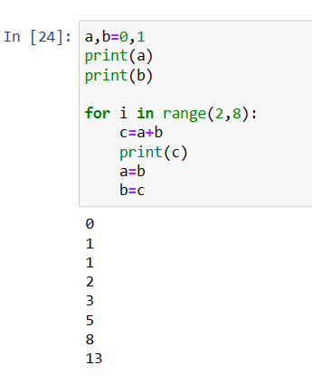

Q18. WAP TO PRINT THE following series

1/1!+1/2!+1/3!....+1/n!

